The “Dublin Bay Prawn”or the Norway Lobster, Nephrops norvegicus, is a very important marine species in the Irish fishery. Irish landings of Nephrops norvegicus are worth over £13.5 million per annum, making Nephrops one of the most valuable fisheries in these waters. Scientists have spent many years researching Nephrops in order to gain a more in-depth knowledge of this commercially important species.

Nephrops is a widely distributed species but despite its common name, the “Dublin Bay Prawn”, this species is not found in Dublin Bay! It is found, however, in the Irish Sea, the Celtic Sea and off the West Coast of Ireland. It is also found from Iceland to Morocco and into the Mediterranean as far as Egypt, occurring at depths from 15m to 800m. Its location is mainly dependent on the availability of soft substrate in which it can construct its burrows. Nephrops spend a great deal of time in their burrows and their emergence from these is related to time of year, light intensity and tidal strength. These factors are often thought to be responsible for huge fluctuations in catch size. Burrows are particularly important to Nephrops as they offer protection from potential predators. One of their main predators is cod, but other species are also known to feed on them e.g. rays and dogfish.
Carapace Length

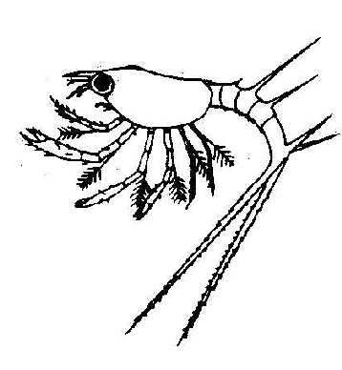
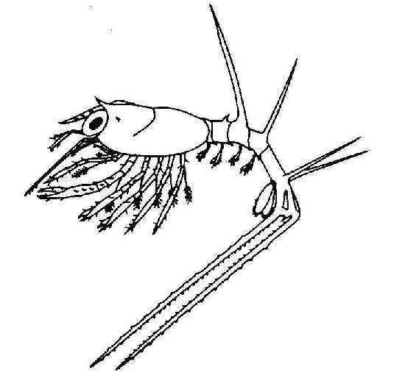
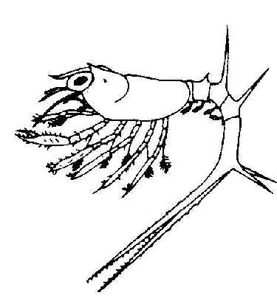
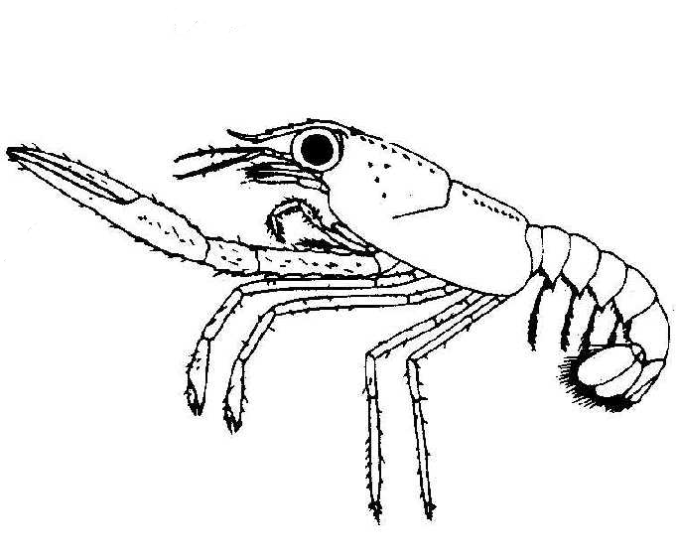
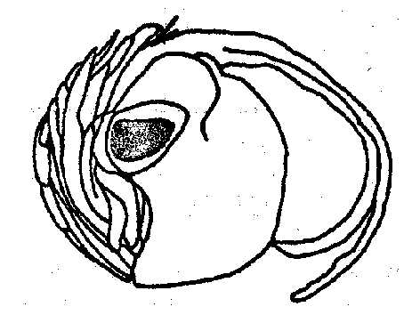
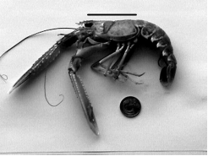

(modified from J.S. Cobb & B.F. Philips, The Biology and Management of Lobsters, 1980).
Stage IV (~16mm -total length)
Stage III
(~12mm -total length)
Stage I
(~6.5mm - total length)
Stage II
(~9mm -total length)
Recently hatched egg
Adult Nephrops
Life Cycle of Nephrops norvegicus

They are particularly vulnerable to predation when they have recently moulted (shed) their old shell and while their new shell has not yet hardened. During the course of their lifetime Nephrops will moult at least once a year. This is because the Nephrops shell cannot grow with the individual and in order to increase in size they must shed the old one and a new larger one will replace it. Nephrops tend to remain in their burrows throughout this period.

Female Nephrops reach maturity at approximately 23 mm CL (carapace length), while male Nephrops are thought to be mature at 26 mm CL. Once mature, the female ovary begins to ripen and slowly
changes colour from cream to dark green through the course of the summer. This colour change can be seen through the carapace (thorax) wall. The eggs are spawned and fertilised in autumn. They are carried on the underside of the female’s tail (abdomen) where they remain for the eight to nine months incubation period. Females tend to remain in their burrows during incubation, thus explaining the disappearance of females from the catch over the winter months. Hatching occurs from April until June producing minute larvae, which bear no resemblance to the adults. These larvae go through 4 stages (3 of which are free-swimming) over a 40-day period prior to becoming a juvenile Nephrops. These juveniles have a carapace length of 2-3 mm. They are thought to share the burrows of the adults for the first months of their lives before constructing their own. Nephrops can grow up to ~ 80mm CL but can be legally caught by the fishery when they are larger than 20mm CL in the Irish Sea and 25mm in the other Irish fishing grounds.

Due to the complex biology and behaviour of Nephrops and its economic importance much work is currently underway to study this species in greater detail.

Nephrops fishing grounds around the Irish coast

Further information:
Similar information leaflets are available from the Marine Institute which cover the following topics :
- What is Fisheries Research?
- Ageing of Fish
- Research Surveys
- Discarding
- The Fisheries Assessment Technician Programme

For more information contact:

Jennifer Whitmore @ 01-8228239 .

Or contact the Marine Fisheries Services Division, Marine Institute, Abbotstown, Dublin 15.

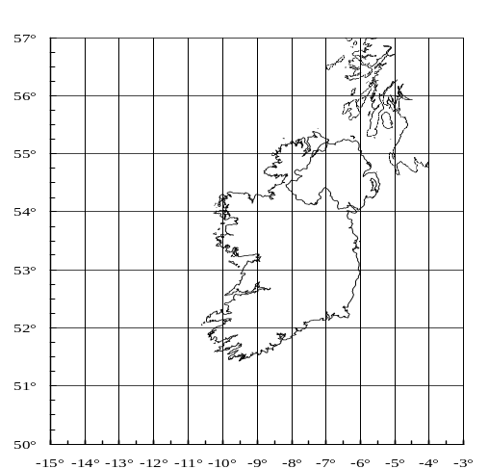

W. Irish Sea Grounds


Porcupine Bank
Marine Fisheries Services Division,
Smalls Grounds
Marine Institute,
Abbotstown, Dublin 15. Eire.
Tel.: 353 . 1 . 8228200
Labadie Bank
Fax.: 353 . 1 . 8205078
E Mail : marine@marine.ie

Cockburn Bank
Web: www.marine.ie

The Dublin Bay Prawn

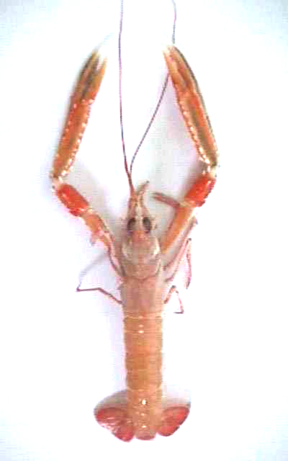

Information Leaflet

